***Cognision******Systems***® is an FDA cleared EEG/ERP**\*** used by neurologists and major pharmaceutical companies including Merck. But, because it's so easy to use it's perfect for all doctors as part of an in-office protocol for evaluation of **Concussion** (TBI), **Post-Concussion Syndrome** (PCS) and **Dementia** including **Alzheimer's Disease**. Accepted by Medicare and insurance. Excellent for objective baseline assessment of athletes. *Cognision-type* *ERP evaluation for TBI is recommended by one of the world's leading evidence based medical guidelines.*

**Cognision Systems® EEG/ERP Concussion Evaluation**

**Mr. James Mathis** *"This is exactly what physicians and attorneys in the PI world have needed for decades. This will now provide an opportunity to not only catch all the cases of MTB injuries which have gone undiagnosed and untreated, but also objectively document those for the direct benefit of patients and clients. At last there will be a vehicle to effectively communicate with the insurance industry all the missed MTB injuries which in the past have complicated recovery and gone uncompensated by the insurance industry."*

**Latha Ganti, MD, MS, MBA, FACEP Brain Injury Researcher** *“In mTBI, there are numerous deficits noted especially challenges with executive functioning, which can reasonably be correlated to dysfunction (EEG slowing) in a certain lobe of the brain.” “Very excited to be part of the team, and especially excited to help mTBI victims. I have seen first-hand how a "simple" MVC can ruin their lives and those of their loved ones.”*

**The Brain Injury Society** *“In fact, motor vehicle accidents (MVA) and falls are responsible for most TBIs suffered by Americans. According to the Centers for Disease Control and Prevention, about 2 million Americans per year experience TBI, with 14.3% caused by traffic accidents and 40.5% caused by falls. That means some 286,000 TBIs result from car crashes annually. The actual number may be much higher, because brain injuries aren’t always immediately obvious after an accident. Indeed, TBI is commonly referred to as a “silent” epidemic because many people do not associate brain injury with concussions—the most common form of TBI.”*

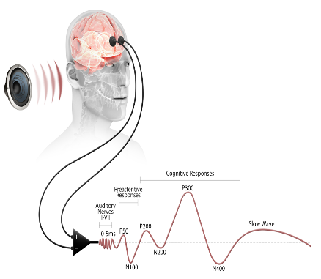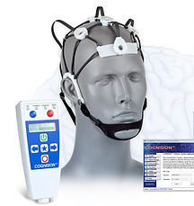

***\*****ERP is Event Related Potential.  An Event Related Potential is the measured brain response that is the direct result of a specific sensory, cognitive, or motor event. An ERP measures brain electrical activity time-locked to a specific event during the EEG for better identification of injury. Often, concussion results from micro trauma resulting from stretched axons and neurons and chemical changes not evidenced on CT or MRI.*

***Cognision Systems***® uses a patented system that digitizes EEG signals collected through its high-quality miniature amplifier via a reusable headset.

**For more information visit**

**Call or Text: Email:**